X-ray Absorption Spectroscopy in Physics, Material Science and Chemistry

A. Anspoks¹, A. Kuzmins¹, I. Pudža¹
¹Institute of Solid State Physics, University of Latvia
*Corresponding author, e-mail: andris.anspoks@cfi.lu.lv

X-ray absorption spectroscopy (XAS) is a powerful tool to study local electronic and atomic structure of solids, liquids, and gases in a wide range of external conditions defined by temperature, pressure, etc. The information on the local electronic structure can be extracted from x-ray absorption spectrum in the vicinity of an absorption edge of an atom, whereas structural information can be determined from the extended X-ray absorption fine structure (EXAFS), having an oscillating character, and located beyond the absorption edge.
XAS can be used to determine very small atomic movements [2], atom distribution functions and local environment of particular chemical element [1, 3] as well to test molecular dynamic models [4]. Since early days XAS is used to study catalysts and chemical reactions [6]. Modern X-ray free electron lasers bring a fs resolution to the structure analysis [5]. Special advantage this method is in determining atomic structure around dopants [7].
In this talk I will give and overview of the modern methods using XAS for various analysis of solids, dopant structure analysis and reactions. Methods will include data analysis and modelling approach developed by our team [4, 8].

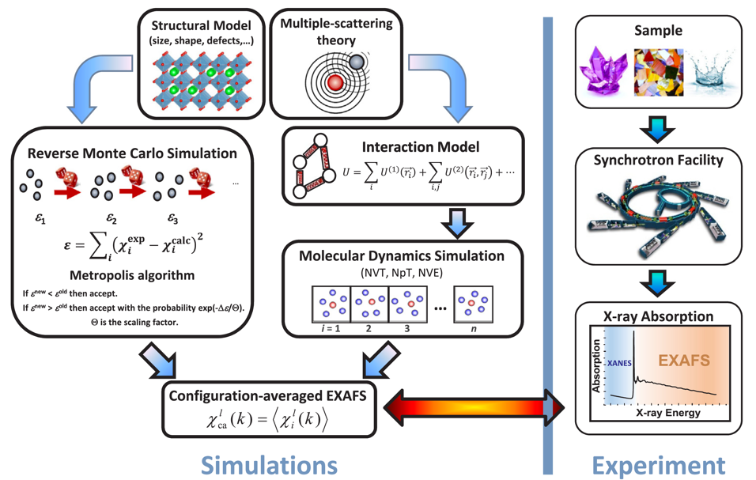

References
- I. Pudza, A. Anspoks, G. Aquilanti, A. Kuzmin, Revealing the local structure of CuMo_{1-x}W_{x}O₄ solid solutions by multi-edge X-ray absorption spectroscopy, Mater. Res. Bull. 153 (2022) 111910. Doi: 10.1016/j.materresbull.2022.111910
- S. Kato, N. Nakajima, S. Yasui, S. Yasuhara, D. Fu, J. Adachi, H. Nitani, Y. Takeichi, A. Anspoks, Dielectric response of BaTiO₃ electronic states under AC fields via microsecond time-resolved X-ray absorption spectroscopy,Acta Mater. 207 (2021) 116681. Doi: 10.1016/j.actamat.2021.116681
- I. Pudza, A. Anspoks, A. Cintins, A. Kalinko, E. Welter, A. Kuzmin, The influence of Zn²⁺ ions on the local structure and thermochromic properties of Cu_{1-x}Zn_{x}MoO₄ solid solutions, Mater. Today Commun. 28 (2021) 102607. Doi: 10.1016/j.mtcomm.2021.102607
- A. Kuzmin, J. Timoshenko, A. Kalinko, I. Jonane, A. Anspoks, Treatment of disorder effects in X-ray absorption spectra beyond the conventional approach, Rad. Phys. Chem. 175 (2020) 108112. [Review] Doi: 10.1016/j.radphyschem.2018.12.032
- Suga, M., Akita, F., Hirata, K. et al. Native structure of photosystem II at 1.95 Å resolution viewed by femtosecond X-ray pulses. Nature 517, 99–103 (2015). Doi: 10.1038/nature13991
- S. Mukerjee, S. Srinivasan, M. P. Soriaga, J. McBreen, Role of Structural and Electronic Properties of Pt and Pt Alloys on Electrocatalysis of Oxygen Reduction: An In Situ XANES and EXAFS Investigation, 1995 J. Electrochem. Soc. 142 1409. Doi: 10.1149/1.2048590
- J.M. Ribeiro, F.C. Correia, A. Kuzmin, I. Jonane, M. Kong, A.R. Goni, J.S. Reparaz, A. Kalinko, E. Welter, C.J. Tavares, Influence of Nb-doping on the local structure and thermoelectric properties of transparent TiO2:Nb thin films, J. Alloys Compd. 838 (2020) 155561. Doi: 10.1016/j.jallcom.2020.155561
- http://www.dragon.lv/exafs/xas.htm

